
Loyalty Tri-V Umph
Cooperation June 2009
Friendship

President-M.Trachsel-586-484-0836 Sec.-D. Angelosanto-734-422-3501
V. President-M. Van Hollenbeke-734-765-2555 Treas.-J. Mackson-734-525-0537

President’s Message

It’s hard to believe that it is already June. It seemed as if spring would never come and now summer is just around the corner. Golf season is in full swing and we are already more than half way through the first half of the season. The number of golfers is way down this season; hopefully we will see more of you out on the links in the weeks to come.Last month we held the Open House at Gateway Golf Club, one of my favorite events of the year. We had a pretty good turn out perhaps helped by the nice weather we had, which is not always the case at the open house. In June we will be initiating my new brother-in-law, Dave Burke. I’d like to personally welcome Dave to the club!

Happy Fathers Day to all you dads!

Mike T

Peg Wendt

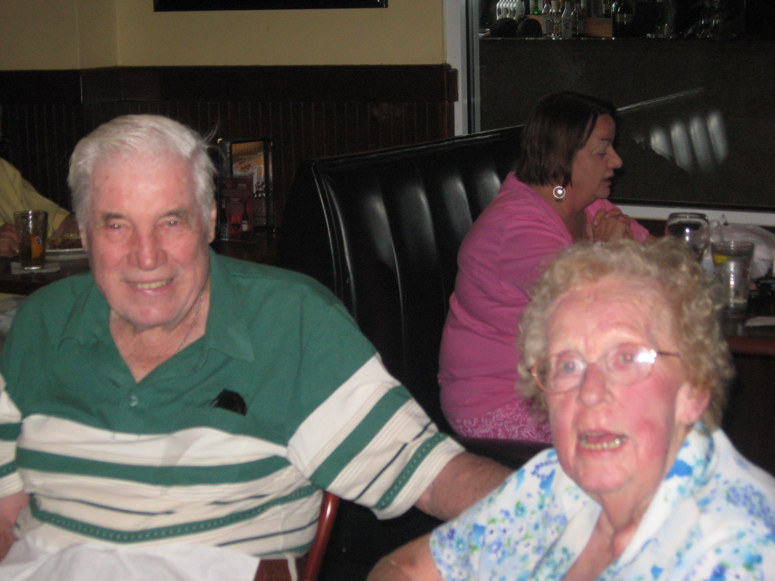
On May 15th, we lost Peg Wendt. Peg was the wife of Bob Wendt for nearly 63 years and the mother of Kathie & Art Dushary. The accident happened a week earlier. She was going in the kitchen and I believe she had another T.I.A. because she blacked out and fell over backward and hit her head on the stove. She went into Fla. Hospital and they discovered a blood clot on her brain. They sent her to Tampa General. She went into a coma and never really recovered. Peg was a great girl despite all the troubles she had over the years. She never complained. Memorial service for Peg will be at St Martin DePores on 57 and Luce Rd in Perrington. The memorial mass will be at 1PM on Saturday, July 18th. A meal will follow at the home of Art & Kathie Dushary. If anyone thinks they might come, maybe they can let Art or Kathie know so they know how much food to have.

Girl’s Club

Girl's Club will be held at the home of Jacqui Schaefer on Wednesday, June 17; at 7 p.m. ALL ladies associated with Tri-V are welcome

Book Club


Next book club is June 22, 2009 at Jacqui Schaefer's--7:00 pm.

Book we're reading is "Three Cups of Tea" by Greg Mortensen and David Oliver Relin.

June Initiation

We would like to welcome Dave Burke and his “Bride” Kim as members of the TRI-V Family. Dave’s initiation took place on June 6th at Walker’s Speakeasy, Redford Mich. Dave was sponsored by Jay Trachsel. There were 28 TRI-V Club Members in attendance. The Club oath was administered by President Michael Trachsel and a reading of deceased Club Members was read by Ton Untener. The traditional reading of the poem “Hand On A Shoulder” was read by Senior Club Members, Bud Massoll, Bill Suchner and Bill Trachsel Sr. The day started with eight Club Members playing golf at noon at Gateway Golf Club. The evening started with a social hour followed by a dinner of prime rib/fish, dessert (furnished by Judy Lardin) and then the ceremony. The evening concluded with socializing. We remind Dave and Kim the words of our founding father, Ray Suchner, “You will get as much out of the Club as you are willing to put into.” Try to be as active as you can in the Men, Girls and Family activities of the Club. The Committee Tim Gies and John Lardin

July Picnic

Saturday, July 25, 2009 is the date for the family picnic. It will be held at Gunnar Mettalla Park, 645 Mettala in Wixom. This is the same location it has been held in the past few years. Picnic begins at 12:00 noon with lunch at 1:00 pm. As in the past 72 years this is a FAMILY PICNIC so bring all of your family with you. The committee would like to ask the Ladies of Tri-V and other families attending to assist in preparing the luncheon buffet. We will be in need of casseroles (always need more), salads, veggies, fruits and of course desserts (preferably those that can be eaten by little ones without a big mess) i.e. cookies, brownies, jello squares, etc. Please prepare enough food to feed 12-15 people since we will not have a prior count. REMEMBER to bring your own place settings, drinks, and ice.

As always there will be games for the children and adults as well. Please e-mail or phone Judy Lardin jalardin@aol.com or Bev Lardin bevlardin@comcast.net 734-404-5132 to let them know what dish you plan to bring. Please, all TRI-V, do your best effort to attend. Any Tri-V member who has sponsored a Prospective Member, please remember to invite them as well. For those wishing to stay later, remember to bring food to grill i.e. hot dogs/hamburgers/chicken.

Final Golf

Where: Gaylord Michigan
When: August 28th, 29th, 30th

We will be staying at Ray’s Retreat Country Inn. I have told them that we will have at least 24 people attending. I need to know if you are planning to attend and a 200.00 deposit per person by May 25th. Please let committee know as soon as possible.

Friday: The Natural
Saturday: The Wilderness
Sunday: Black Forest

Cost will be $260.00. This will include 2 dinners and 2 breakfasts along with prize money. Ray’s Retreat is a 17 unit Inn. We will have the whole Inn. We have a room for cards at night. The Inn also has a volleyball court and horse shoes along with a bonfire each night.

NOTE: If you haven't paid the 200.00 for final golf and are planning on going please send to Jeff ASAP. The last 60.00 is due by July 15th. I still need 6 more golfers that want to go. If not we are going to open up to anybody that wants to go. I locked in the cost for 24 golfers.
Hope to have a good turn out so let us know ASAP if you plan on attending. Committee: Matt VanHollebeke, Geoff Steinhauer, John Mackson, Jeff Trachsel

Tri-V Steak Roast
The Steak roast will be held at Gunnar Mettala Park in Wixom on Aug. 8th. The park is located on the south side of Maple Road just west of Beck. Plan to arrive between 3:15 to 3:45. We will eat at 4:30. Don't forget to bring your chairs, table place setting and beverages. The menu will be steak, corn on the cob, salad, dessert and coffee will be provided. There will a sign up sheet at the picnic. If you are not attending the picnic please call Jerry Gies to let him know that you will be attending the Steak Roast 248-437-2219 or e-mail bjg151@sbcglobal.net. Please do so by July 27. Thanks, Jerry

Tri-V Wives Weekend Getaway
It is all set. We are off the Alma, Michigan on August 28th & 29th. We will stay at the Saravilla Bed & Breakfast. So far we have filled all but one spot (13 ladies need 1 more). The cost for 13 ladies is $98 per person for both night stays and 2 breakfasts but if we have 14 it will only cost $91 per person. There will be an additional cost for 2 lunches and 2 dinners but that will be discussed next month. If you would like to be that 14th just email me, Sherry, (rpkuhr@aol.com) or call 248-888-9335 to let me know. So far we have Geri, Sherry, Kathie, Victoria, Karlyn, Ellie, Dolores, Blondie, Judy, Jacqui, Sue Dunham, Donna Clingerman, and Marian going. Don't miss out on this great opportunity to laugh and get to know each other better. Also, of those named please let me know who would like to drive. Your committee, Sherry Kuhr, Kathie Dushary, Geri Ruetenik

Trifles

From the J. Lardins
Judy and John Lardin were the guest of Jacqui and Jack Schaefer at their summer cabin in Northern Michigan over the Memorial Day Weekend. While there they were joined by Peg and George Hoffman for golf on Friday and Saturday then attending the beautiful wedding of Dave and Kim Burke in Charlevoix. They returned the following Tuesday and on Thursday Judy and John headed south to spend six days in Corpus Christi Texas with Larry, Kim and grandchildren. The weather in Texas was already in the very low 90s and the humidity in the mid 80s and it was very uncomfortable. While in Texas they spend a lot of running attending the grandkids kick ball, ballet and baseball game. Add to that a birthday get together for daughter-in-law Kim’s older sister and it ended up being a tiresome trip. Larry and John did manage to get in a round of golf at a new high price golf course along the Gulf Coast. It was bearable playing golf as there is always a breeze from the Golf Coast to cool you off. They ran into some minor flight problems returning home on Tuesday but did make it in time for John to make the golf league in Livonia. All Judy keeps saying is “Things have to slow down sooner or later!” John’s response “Oh yah, you know that is going to happen.”

From the Babs & Wendy Wagner
As a family and from my mom personally, we would like to thank all the Tri-V members for the many cards, letters and well wishes she received for her 90th birthday. Alex and I were back home to celebrate with her. I read all of your cards to her....she received over 50!!! What an out pouring of love and affection she felt from you. It meant more that words can say. She also wants to thank each and every person in Tri-V who has visited and made her life more cheery. She really enjoys the card playing and chit-chatting sessions. So again thanks Tri-V for all your love and support.
Wendy and Babs Wagner

From Bob Wendt, Kathie & Art Dushary
We would like to THANK everyone for all your cards and prayers during our time of sorrow.

Calendar of Events

June July
5th Initiation 6th Men’s Golf
8th Men’s golf 13th Men’s Golf
15th Men’s golf 20th Men’s Golf
17th Girls’ Club Mtg (Schaefers) 25th Family Picnic
22nd Book Club (Schaefers) (Gunnar Mettala Park)
22nd Men’s golf 27th Men’s Golf
29th Men’s golf

June Birthdays July Birthdays
2nd Jim Delanoy 4th Dion Angelosanto
8th Marilyn Myers 5th Roy Lockhart
12th Jay Trachsel 21st Michael Trachsel
14th Virginia Buckley
22nd Joan Fischer

June Anniversaries July Anniversaries
6-4-94 Ken & Diane Plocharczyk 7-9-83 Geri & Dave Ruetenik
6-5-48 Bill & Shirley Suchner 7-14-45 Bill & Onallee Trachsel
6-14-02 Dion & AnneMarie Angelosanto 7-17-65 Terry & Ellie Connolly
6-21-08 Mike & Bev Lardin
6-22-68 Lee & Marion Anderson
6-23-01 John & Robyn Mackson
6-29-63 John & Judy Lardin &
Tom & Bonnie Untener

MEMORIES FROM THE JUNE 1994 ISSUE OF TRI-V UMPH

We are happy to say that there were no serious illnesses to report in June of 1994 though there were still members of our TRI-V Family in need of our prayers. The health of original member, Jack Henry, has been deteriorating rapidly and so he and Veda have been forced to move from their Scottsdale home to an assisted living facility. Lu Wagner was found to be suffering from macular degeneration in the left eye but a second opinion advised no laser treatment following this Lu and Dottie Wagner made arrangements to live in a retirement home south of Lake Wales. Other activities reported were the June Initiation of Jack Schaefer to take place on June 4th at Bogie Lake Golf Club and the Family Picnic to be held at Lakeshore Pavilion, Novi, on Saturday, June 26th. The “ladies” of TRI-V were coordinating the food. The Girl’s Club July Swim was set for July 21st at the home of Blondie Forsyth.
TRI-V Girl’s “Run-away Weekend” was to be at The Riviera Resort, Houghton Lake Area the weekend of August 27th-29th. TRI-V’S 62nd Anniversary Party was held on May 1st at the Water Club Grill in Plymouth. Our Master Of Ceremonies for the evening was Earl Tishler who took us all down memory lane with TRI-V. Earl briefly recounted TRI-V’s history. There were fifty-eight Members and guest in attendance. After the installation of the new Officers a game of TRI-V Trivia produced by Jane Trachsel was played.

MEMORIES FROM THE JUNE 2004 ISSUE OF TRI-V UMPH

This was a hard month to report on the memories. What has made it so hard is there are pages missing from my copy or there were no trifles in the paper. After checking the numbers at the bottom of each page I realized that there were three paragraphs of trifles in the paper and they were on page 5. Ken and Diane Plocharczyk were heading to Florida and Betty Galloway’s grandson was going to Nepal with a group from his Church. The main paragraph enlightened us on the physical ailments of the Connolly Family. Terry knee replacement on November 11, December 13th Ellie’s broken shoulder, April 1st Ellie’s arthroscopic knee surgery and their son Frank with total hip replacement on May 13th. The paper was not a total blank as there was the calendar of events listed on the first page and the web address for TRI-V. The TRI-V Picnic is set for Rotary Park, Livonia on July 11th. Judy Lardin was coordinating the food and the Girls Club Swim was to be at Blondie Forsyth’s on July 14th followed by the Steak Roast at Gilbert Willis Park, Wixom, on August 7th. The Girls Weekend was to be at the Northwoods Lodge, Indian River, Mich., the weekend of Aug 13th-15th and Men’s Final Golf the weekend of August 20th-22nd in Northern Michigan. This wraps up another trip down Memory Lane. Thanks to the various committees for furnishing articles for the June 2004 issue of TRI-V Umph or there would have been no need for a paper that month. Fathers Day will be upon us as you read this issue. If you failed to take the time last month to spend that little time with Mom for Mothers Day then you still have a chance to get into good graces for Dad. Take that extra minute to spend some time with Dad or Grandpa. Let him know how important he is to you and to your children. Too many times we are in touch with Dad when we want or need something from him. Let this day be different. Spend some time during the week to just sit and chat with him and live those memories that you might remember happening when you were younger or better let ask him, let him tell you things that you never knew happened or don’t remember happening with him. If you are not fortunate to have your Dad or Grandpa with you then share with other members of your family or the TRI-V family special things that you remember. In the mean time continue to pray for each other, look after each other until we see you in print next month, the Good Lord willing.

